Since August 1996, Saskatoon Centre has made its telescopes available for rent to RASC members on a monthly basis. We have six telescopes and one set of eyepieces for rent:
1. 3.1 inch Tasco refractor
2. 4 inch Astroscan compact reflector
3. 6 inch rich field reflector
4. Meade 8 inch skywatcher - telescope 1
5. Meade 8 inch skywatcher - telescope 2
6. Meade 8 inch skywatcher - telescope 3
7. Eyepieces☹To be rented as a single unit)
a) 2”/1.25” Hyperion 5mm 68 degrees
b) 2”/1.25” Hyperion 8mm 68 degrees
c)` 2”/1.25” Hyperion 13mm 68 degrees
d) 2” Knight OWL 30mm 80 degrees

BASIC REQUIREMENTS
The Renter must be a member in good standing of the RASC. Should the renter cease to be a member while in possession of a rental telescope, said telescope must be returned immediately.
RENTAL RATES
1. $10 per calendar month. $5 for less than half a calendar month.
2. Should you feel that these rates are too outrageous, borrow the telescope anyway and pay
what you deem to be fair.
3. Make your payment when you return the scope.
a) Make cheques payable to "Saskatoon Centre RASC".
b) If you pay cash, be sure to get a receipt for your payment from the curator.
RENTAL PROCEDURE
1. Email our current telescope curator (Errol Frazer-Harrison) with the following information:
a) Your name and email address.
b) The telescope you wish to borrow.
c) When you want to pick up the telescope.
d) How long you anticipate borrowing the telescope.
2. The curator will contact you and, should the telescope be available, set up a time and date
for pick-up at the Observatory on the University of Saskatchewan campus.
3. You may keep the telescope for a minimum of one month.
4. Should some other member request the telescope while you have it on loan, you will be
asked to return the telescope at the end of your month. If no one requests the telescope,
your loan agreement can be extended for a second month to an absolute maximum of one year
(12 months) at which time the telescope must be returned for inventory and condition check.
Have fun with the telescope and thanks for supporting our Centre!
TELESCOPE AVAILABILITY
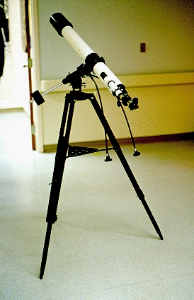

3.1 inch Tasco Refractor
- Available for loan
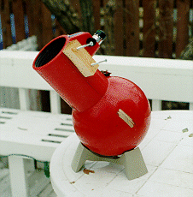
4 inch Astroscan Reflector
- Unavailable – under repair
------------------------------------------------------------------------------------------------------------------------------------------
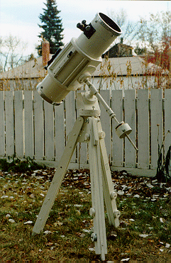

6 inch Rich Field Reflector
- Unavailable - under repair
------------------------------------------------------------------------------------------------------------------------------------------
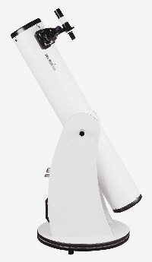

8 inch Meade Skywatcher #1
- Borrowed by Andrea Regier June 28, 2015
--------------------------------------------------------------------------------------------------------------------

8 inch Meade Skywatcher #2
- Unavailable - under repair
------------------------------------------------------------------------------------------------------------------------------------------

8 inch Meade Skywatcher #3
- Borrowed by Alan Blanchet August 1, 2015
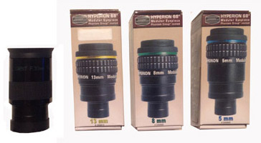
30mm 13mm 8mm 5mm
Eyepiece Set
- Available for loan
_____________________________________________________________________________________

